TELECOMMINICATION NETWORKS PROTOCOL MODELS
OSI Reference Model
• RM OSI (Reference Model for Open Systems Interconnection (bagli olma) ) is a set of rules and standards that are necessary for an exchange of information among (arasinda) open systems.
• Open means open for communication.
• The system is composed (olusmak) of one or more computers, corresponding (uyumlu) software equipment, outdoor equipment, terminals, human operators, physical processes, means (arac) of information transmission, etc.
• The system interconnection (bagli olma) means not only data transmission but also the ability of systems to cooperate (birlikte calismak).
• RM OSI was created by the International Organization for Standardization (ISO) in the years from 1977 to 1984.
• RM OSI consists of 7 layers. The highest (7th) layer is the interface to the user’s application, the lowest (1st) layer is the interface to the physical transmission media. The neighboring layers have also common interface for the exchange of information between them.
• The features of layers are modeled by entities (varlik). The entity is an independent program or a technical component (bilesen) which realizes (gerceklestirmek) one or more functions of the layer.
• Communication between entities is described by communication protocols. Peer (es, akran) entities from different systems exchange information in a form of protocol data units (PDU). An entity from the under-laying layer offers (sunmak) a service to an entity from the upper laying layer through a service access point.
• Intermediate (ara, araci) devices in the network don‘t usually need functions of all 7 layers so they have only lower layers and some upper layers are missing (eksik).
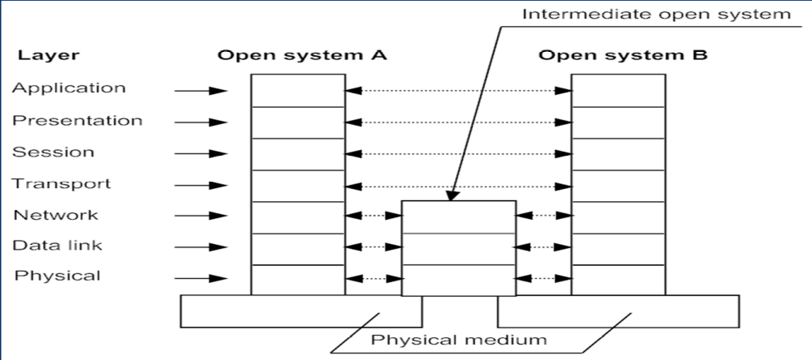
RM OSI of two end systems and one intermediate system
• As (while) a data message travels through layers from the highest to the lowest layer, each layer can add its own control information which is important for peer (es) layers of other systems. This process is called encapsulation.
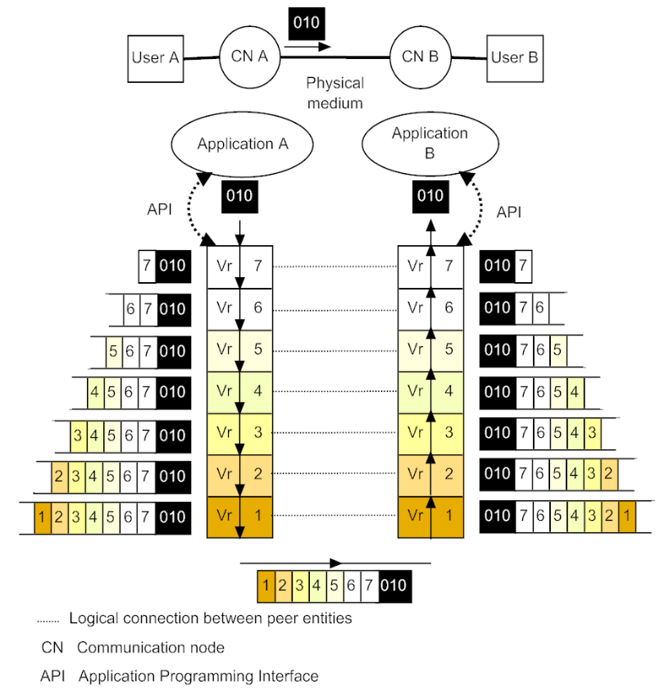
Process of Encapsulation

General Functions of Layers
• They are common for all layers. They describe services between neighboring layers.
• Multiplexing/demultiplexing of connections
Splitting (bolunme) /recombining (yeniden birlestirme) of connections
Segmenting (bolme) /Reassembling (birlestirme) of data units
Blocking/Deblocking of data units
Flow Control
Sequencing (siralama) of data units
Acknowledgment (onaylama) of data units

Characteristics of RM OSI Layers
• 7th – Application layer
• 6th – Presentation layer
• 5th – Session layer
• 4th – Transport layer
• 3rd – Network layer
• 2nd – Data link layer
• 1st – Physical layer
• 7th – 4th layers – terminal oriented layers – they are implemented only in terminals
• 3rd – 1st layers – network oriented layers – network devices usually use only these layers (all or some of them)
Application Layer
• It is a layer that provides the interface between applications we use to communicate and the underlying (temel, altta yatan) network over which our messages are transmitted.
• Application Layer protocols are used to exchange data between programs running on source and destination hosts. There are a lot of Application Layer protocols and new protocols are still being developed (e.g. HTTP, FTP, SMTP, POP3, etc.).
• PDU at this layer is called message.

Presentation Layer
• Coding and conversion (donusturme) of application layer data to ensure that data from the source device can be interpreted (yorumlanmak) by the appropriate (uygun) application on the destination device (e.g. ASCII, JPEG, MPEG, etc.).
• Compression (sikistirma) of data in a manner (tarz) that it can be decompressed (basinci azaltilmis) by the destination device.
• Encryption (sifreleme) of data for transmission and decryption (sifre cozme) of data after its receipt (alindi) by the destination.

Session Layer
• As (gibi) the name of the Session Layer implies (belirttigi), functions at this layer create and maintain (korumak) dialogs between source and destination applications. The Session Layer handles (kullanmak) the exchange of information to initiate (baslatmak) dialogs, to keep them active, and to restart sessions that are disrupted (bozulmus) or idle (bos) for a long period of time.
Transport Layer
• The Transport Layer provides a segmentation (bolunme) of data and the control necessary to reassemble (yeniden birlestirmek) these pieces into various communication streams. Its primary responsibilities to accomplish (gerceklestirmek, yerine getirmek) this are:
– Tracking (izlemek) individual communication between applications on the source and destination hosts.
– Segmenting data and managing each piece.
– Reassembling segments into streams of application data.
– Identifying (belirleme, tanima) different applications.
• Examples of protocols: TCP, UDP (from TCP/IP model).
• PDU at this layer is called segment.
Network Layer
• The Network Layer provides services to exchange individual pieces of data over the network between identified end devices. To accomplish this end-to-end (uctan uca) transport it uses four basic processes:
– addressing of network devices,
– encapsulation and decapsulation of data,
– routing (yonlendirme) within connectionless transmission,
– signaling within connection-oriented transmission.
• Examples of protocols: CLNP – Connectionless Network Protocol (from OSI model), IP (from TCP/IP model).
• PDU at this layer is called packet (sometimes also datagram).

Data Link Layer
• The Data Link Layer provides a means (arac) of exchanging data over a common local media.
• The Data Link Layer performs (gerceklestirmek, yerine getirmek) these basic services:
– It allows (izin vermek, saglamak) upper layers to access media using techniques such as framing .
– It controls how data is placed onto (-e) the media and received from the media using techniques such as media access control and error detection.
– Using a flag it synchronizes the communication between the source and the destination device.
• Examples of protocols: Ethernet, Token Ring, Frame Relay, HDLC, PPP, IEEE 802.11.
• PDU at this layer is called frame.
Physical Layer
• The Physical Layer provides a means of transporting bits that make up a data link layer frame across the network media.
• The delivery of frames across (uzerinden) local media requires the following physical layer elements:
– physical media and associated (birlesmis) connectors,
– a representation (gosterim, temsil) of bits on the media (electrical, optical or radio signal),
– encoding of data and control information,
– transmitter (verici) and receiver circuitry (devre sistemi) on network devices.
• Examples of standards: EIA/TIA standards for UTP and fiber optic cables, ISO 8877 for RJ-45 connector, EIA RS-232, IEEE 802.11a/b/g/n.
TCP/IP Protocol Stack
• The TCP/IP stack was developed at the initiative (girisim) of the U.S. Department of Defense to ensure connectivity between an experimental (deneysel) ARPANET network and other networks.
• TCP/IP was implemented as a protocol suite (takim) for a heterogeneous network environment. The TCP/IP stack is named after its most popular protocols - TCP and IP – that were developed in the 70s and 80s of the 20th century.
• Nowadays, this stack is used for communications among computers connected to the Internet and in numerous other networks.
• Advantages of the TCP/IP stack:
- fragmenting (parcalanmak) of IP packets according to used data link layer technology,
- flexible addressing system.
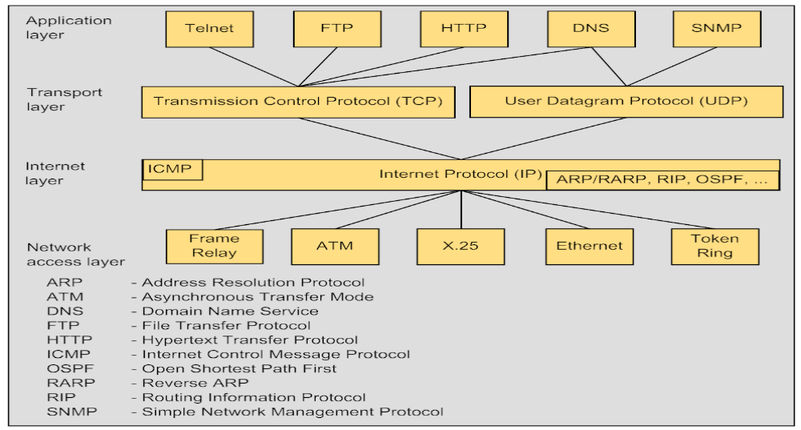
TCP/IP protocol stack (chosen protocols)
Layers in TCP/IP Protocol Stack
Application Layer
• The Application Layer corresponds (karsilik gelmek) to three upper layers of OSI model (Application, Presentation, and Session Layer). It combines services provided by the system to user applications.
• There is a large number of protocols and services of the Application Layer – File Transfer Protocol (FTP), terminal emulation protocol (telnet), Simple Mail Transfer Protocol (SMTP), Hypertext Transfer Protocol (HTTP) etc.
Transport Layer
• The Transport Layer can provide two types of services to the upper layer – a guaranteed delivery by Transmission Control Protocol (TCP) and the best effort delivery by User Datagram Protocol (UDP).
• The functions of TCP and UDP include a role of the link between the Application Layer and the underlying Internet Layer. The Transport Layer takes a job of data transmission with specified quality from the Application Layer and informs (bildirmek) it after accomplishing this task. On the other hand, TCP and UDP use the underlying Internet Layer as a kind of tool (arac), which is not characterized by high reliability but is capable of transmitting the packet through the internetwork.
Internet Layer
• The Internet Layer is at the core of the entire (tum, butun) TCP/IP architecture. Its functions correspond to the OSI model network layer.
• The Internet Protocol (IP) is the main protocol of the Internet Layer. Its tasks include packet forwarding between networks from one router to another until the packet reaches the destination network. In contrast (tersine, aksine) to the application and transport layer protocols, IP is installed (kurulmak) not only on all hosts (terminals) but also on all routers (gateways). IP is a connectionless datagram protocol operating (calismak) according to the best effort principle (en iyi caba ilkesi).
• Protocols that accomplish auxiliary (yardimci) functions in relation to (hususunda) IP are often classified (siniflandirilmak) as belonging (ait olmak) to the TCP/IP Internet Layer. The list of these protocols includes routing protocols such as a Routing Information Protocol (RIP) and Open Shortest Path First (OSPF), involved (ilgili) in studying network topology, determining (belirlemek) routes and creating routing tables that help IP forward packets in the direction needed.
• From the same reason, two other protocols can also be classified as belonging to the Internet Layer: Internet Control Message Protocol (ICMP), intended (tasarlanmis) for transmitting information about packet transmission errors from the router to the information source, and Internet Group Management Protocol (IGMP), used for packet forwarding to several addresses simultaneously (multicasting (coga gonderim) ).

Network Access Layer
• Network Access Layer is responsible for organizing (duzenleme) an interaction (etkilesim) to network technologies, used in networks that form the internetwork. TCP/IP considers (dikkate almak) any network included into the internetwork a tool for transporting a packet to the next router within the route. Hence (bundan dolayi), the task of providing interface between TCP/IP technology and any other technology of the intermediate network is reduced (indirgenir) to the following tasks:
- defining the method of encapsulating the IP packet in the PDU of the intermediate network,
- determining the method of translating network addresses into addresses adopted (kabul edilen) by the technology used by this intermediate network.
• Such approach (yaklasim) makes the TCP/IP Internetwork open for the incorporation (birlesme) of any other network, independent of the internal (dahili) data transmission technology used in that network. For each technology used in the network included in the internetwork, it is necessary to develop specific interfacing tools. The Network Access Layer is not strictly (tam olarak) regulated (duzenlenmek). It supports many different network technologies – Ethernet, FDDI, X.25, Frame Relay, ATM, PPP etc.
Internet Protocol (IP)
• IP function supports connection to the underlying technologies of constituent (kurucu) networks.
• IP is a connectionless protocol. This means that it processes each IP packet as an independent data unit that has no relation to other IP packets.
• If any error has occurred (olusmak, meydana gelmek) in the course (seyir) of packet forwarding, IP does not initiate (baslatmak) any actions to correct this error – IP implements the best effort policy.
• Nowadays, IP version 4 is used but IP version 6 which has better Quality of Service (QoS), multicasting and security support starts to be used. First of all, IPv6 offers enough addresses for the growing Internet.
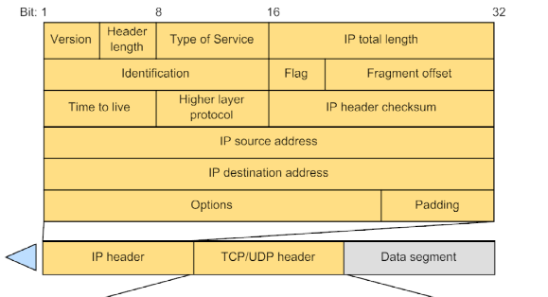 Format of IP packet, TCP segment and UDP segment
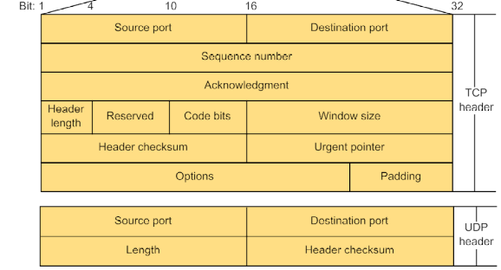
Transmission Control Protocol (TCP)
• To establish (kurmak, yapmak) reliable data delivery, TCP makes provisions (hukum) for establishing a logical connection, which allow it to number packets, acknowledge their receipt and ensure retransmission of any lost packet. It can also detect and discard duplicate (kopya, ayni) packets and deliver the packets to the Application Layer in the order in which they were sent. In this way, TCP ensures error-free delivery of the byte stream formed (olusturulmus) on one host to any other host connected to the internetwork.
• TCP allows the objects on the source and destination hosts to support data exchange in the duplex (cift yonlu) mode.
• TCP divides the message into the segments and passes (gecirmek) them to the underlying layer. After these segments are delivered by the Internetworking tools to the destination host, TCP reassembles them into the original message.
• Application protocols using TCP: HTTP, FTP, SMTP etc.

User Datagram Protocol (UDP)
• UDP is the simplest datagram protocol used when a problem of reliable data exchange is either not important or is solved by the tools of the higher layer, the Application Layer.
• It operates according to the best effort principle.
• Application protocols using UDP: TFTP, SNMP, DNS etc.

Real-time Transport Protocol (RTP)
• RTP supports end-to-end real-time applications like audio (VoIP) or video transmissions. It is designed also for a multicasting.
• It is a simple protocol which uses UDP for its transmission.
• It does not support QoS but it uses RTCP (RTP Control Protocol) for exchanging information between source and destination hosts that is used for the control of the quality level of the data transmission.

Network Management System
• The distributed nature (daginik yapi) of a large-scale network makes its operation impossible without a centralized (merkezilesmis) system that would automatically collect information on the state of various network devices and pass this information to the network operator.
• Network management system comprises (kapsamak, icermek):
– Agents - Agents are software modules that reside (bulunmak) in network devices. They collect and store management information such as the number of error packets received by the network device.
– Managed object - A managed object is a characteristic of something that can be managed. For example, a list of currently (su anda) active TCP sessions (oturum, donem) in the particular (belirli, ozel) host computer is a managed object. Managed objects differ from variables, which are particular object instances (ornekler). Using our example, the object instance is the single active TCP session in the particular host computer.
– Manager – A manager is a software that initiates management operations and receives management information from agents (solicited (istenen) or unsolicited traps (tuzaklar) ).
– Management Information Base (MIB) - A MIB is a collection of managed objects residing (bulunan) in a virtual information store. Collections of related (ilgili) managed objects are defined in specific MIB modules. MIB has a tree structure.
• Example of a network management software is SNMP (Simple Network Management Protocol).
• Examples of managed attributes: memory size and utilization (kullanim), CPU utilization, interface speed, traffic load, etc.
• Tasks of network management system can be divided into the following five functional groups:
1) configuration management,
2) fault management,
3) performance management,
4) security management,
5) accounting (muhasebe) management.

Telecommunication Management Network
• The Telecommunication Management Network (TMN) is a physically separated network for the management of telecommunication networks and services. It has following benefits (faydalar):
– The management is independent on the load of the telecommunication network.
– Management information about the network or service is transported independently of network devices which enables to be informed (bilgilendirilme) about the network condition at each moment.
– Network devices configuration can be prepared in a busy time and realized (gerceklestirilmek) when the traffic is low.
– TMN can be used in a multivendor (cok yonlu satici) telecommunication network.

